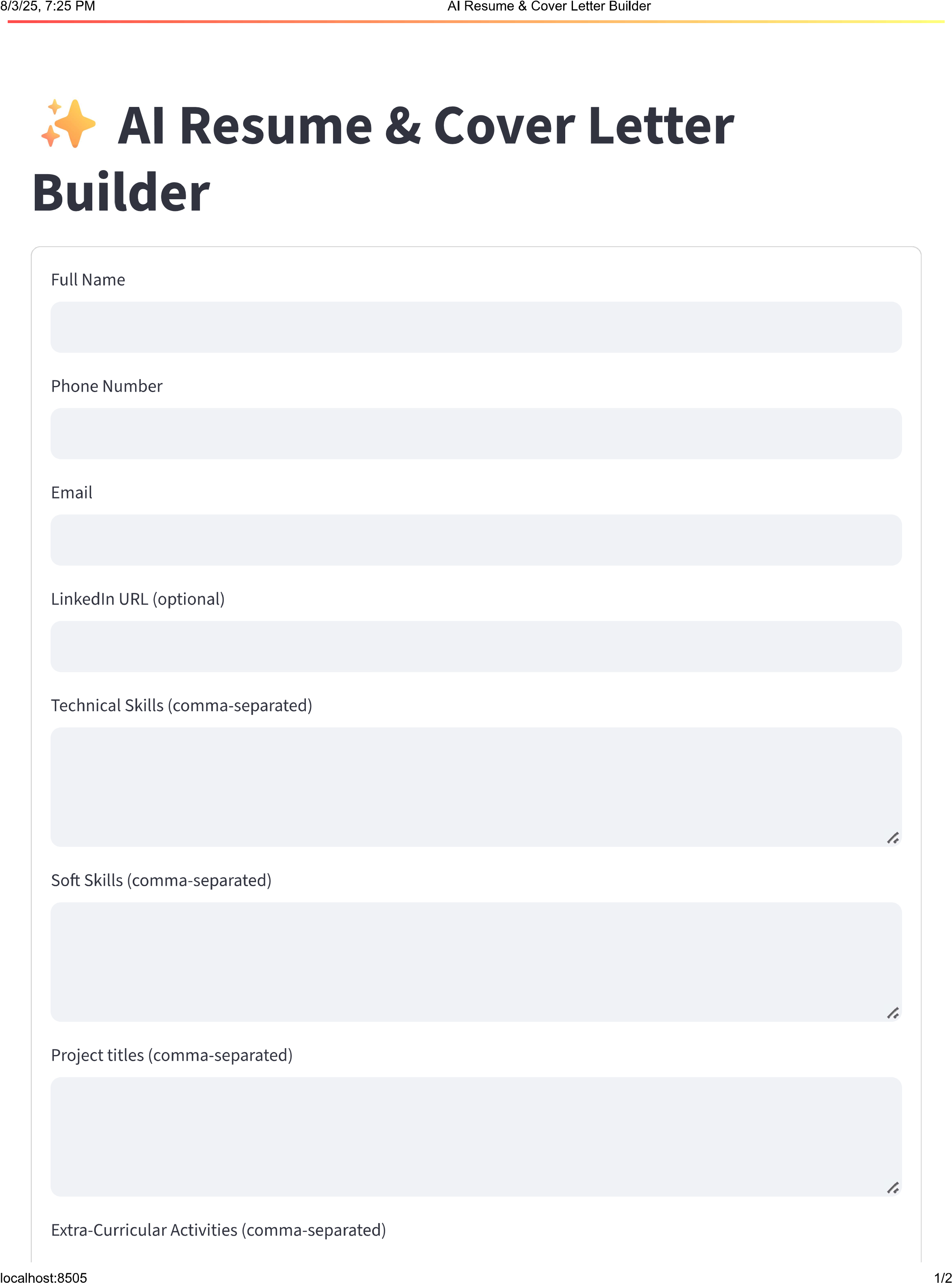

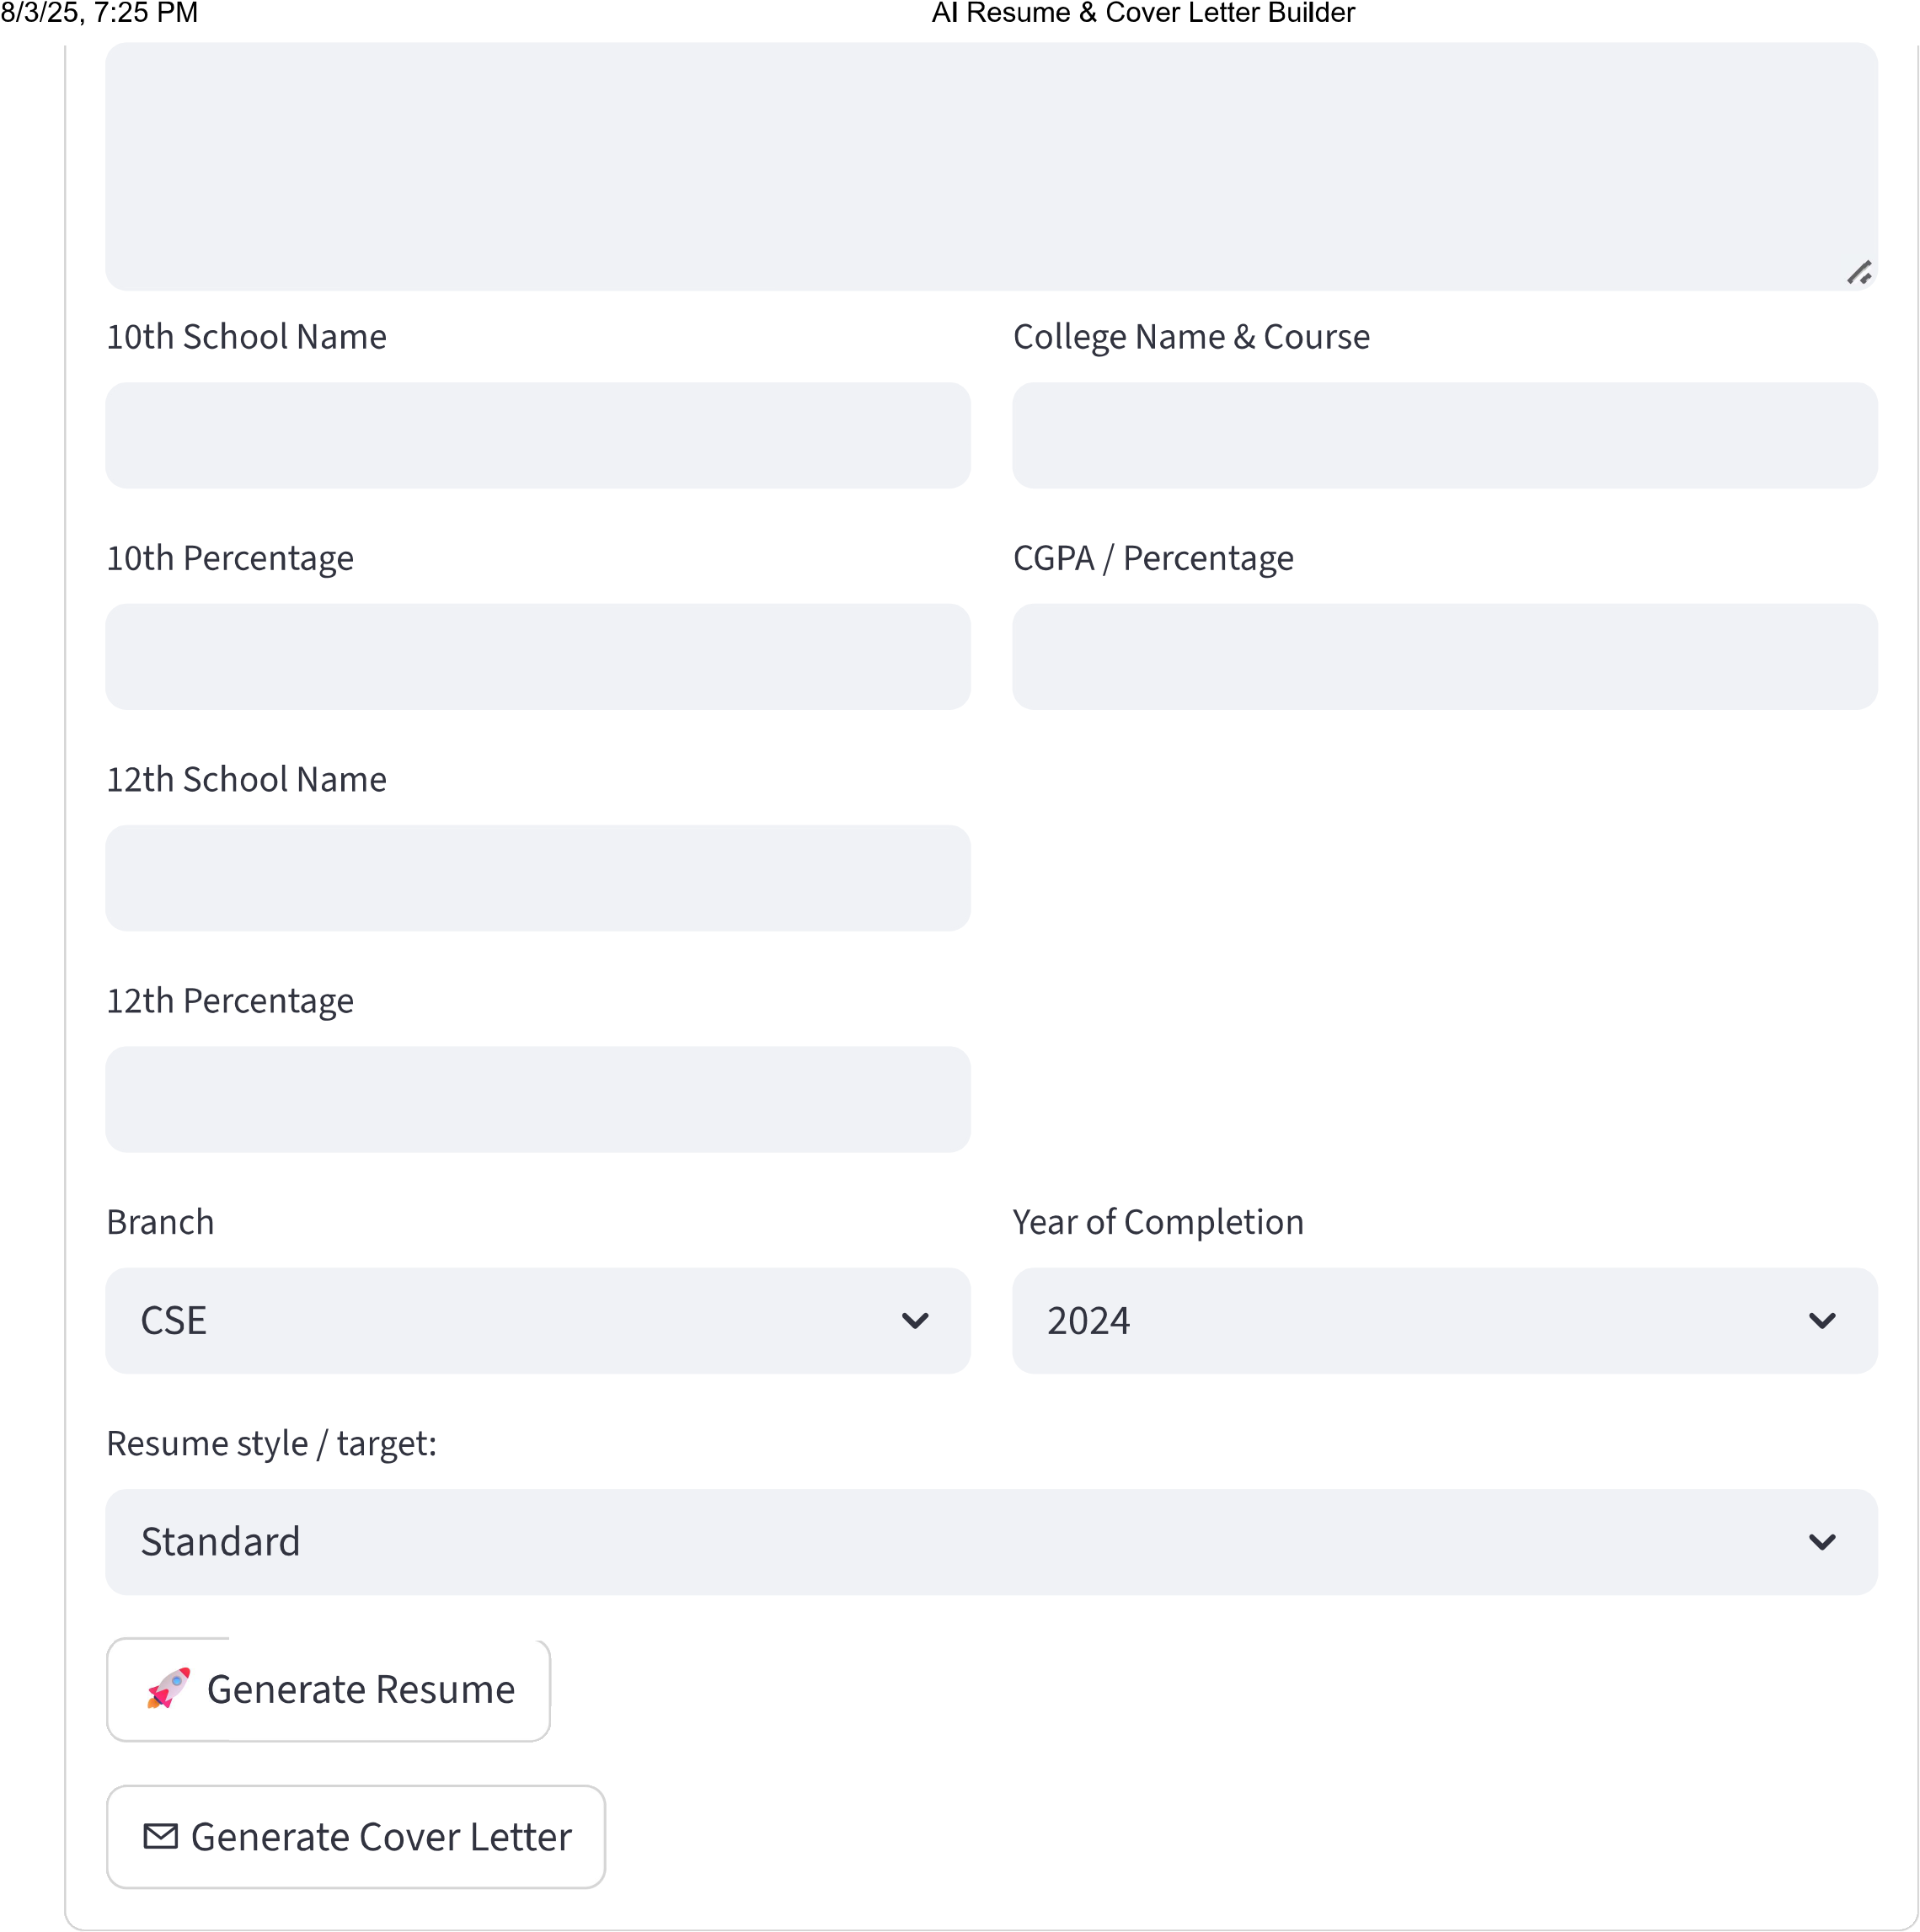

**AKSHAJ KUMAR SAHU**

9809866587

| akshajkumarsahu12345gmail.com |

**Career Objective**

Myself AKSHAJ KUMAR SAHU, a driven and results-oriented individual with a strong passion for

software development, seek to leverage my technical expertise in Java and C programming

languages to drive innovation and growth in a dynamic organization.

**Education**

Branch: CSE, CGPA: 8.45, Year: 2027 at United College Of Engineering and Research.

Achieved 80.1% from Boys High School in 12th.

Secured 83.33% from Boys High School in 10th.

**Academic Projects**

AI RESUME BUILDER

Developed a sophisticated AI-powered resume builder utilizing Python, machine learning

algorithms, and data visualization techniques to create personalized resumes for job seekers.

+ Tools used: Python, NumPy, Pandas, Matplotlib.

+ Achievement: Successfully built and deployed the AI RESUME BUILDER platform, receiving

positive feedback from users.

+ Impact: Enhanced job seekers' employability by providing them with tailored resumes that

showcase their skills and achievements.

**Technical Skills**

Java

C

**Soft Skills**

Leadership: Proven track record of effectively leading teams to achieve goals, fostering

collaboration, and driving results-oriented outcomes.

**Extra-Curricular Activities**

Cricket

Utilized strategic planning and teamwork skills during cricket matches to lead my team to victory in

the college tournament.

*Generated by AI Resume Builder*

**AKSHAJ KUMAR SAHU - Cover Letter**

9809866587

| akshajkumarsahu12345gmail.com |

As I reflect on my academic and professional journey, I am reminded of the invaluable experiences

that have shaped me into a capable and driven individual. With a strong academic foundation in

Computer Science and Engineering (CSE) from XYZ University, I am confident that my skills and

expertise will be a valuable addition to your organization.

Throughout my undergraduate studies, I consistently demonstrated a keen interest in developing

innovative solutions that leverage cutting-edge technologies. My academic record speaks volumes

of my dedication and perseverance, with a CGPA of 8.45 and a range of projects that showcase my

technical prowess. Notably, my AI Resume Builder project stands out as a testament to my ability to

conceptualize and execute complex ideas. This project allowed me to explore the intersection of

artificial intelligence and natural language processing, resulting in a tool that can assist job seekers

in creating dynamic resumes.

As I look ahead to the next chapter in my professional journey, I am excited about the prospect of

applying my technical skills to drive meaningful results. With proficiency in Java and C programming

languages, I am confident that I can make a positive impact in a fast-paced and ever-evolving

industry like yours. My strong foundation in computer science has equipped me with a unique blend

of analytical and problem-solving skills, allowing me to tackle complex challenges and deliver

innovative solutions.

I would be thrilled to discuss my qualifications further and explore how my skills align with your

organization's goals and objectives. Please feel free to contact me at 9809866587 or

akshajkumarsahu12345@gmail.com to schedule a conversation. You can also find me on LinkedIn

at [insert link]. I am eager to bring my expertise and enthusiasm to a new role and contribute

meaningfully to the success of your organization.

Sincerely,

Akshaj Kumar Sahu

*Generated by AI Resume Builder*